
NATIONAL UNIVERSITIES OF MODERN
LANGUAGES
FACULTY OF ENGINEERING AND COMPUTING
DEPARTMENT OF SOFTWARE ENGINEERING

Course Name: WEB-II
Assignment No./ LAB – Task /Project LAB 5: Working with React JS Components
Date: 10 Oct, 2025
Submitted by
Class: BSSE (VII) Section - Sessions (M/A) Afternoon
Name: Zulqarnain hassan Roll No. Sp-21370
Submitted to
Instructor Name: Mr. Danish
To be filled by Instructor
Instructor Comments:
Marks Obtained: Total Marks:
CLO No. :

LAB 5: Working with React JS Components
- Follow the above steps to add Tailwind css into your web page

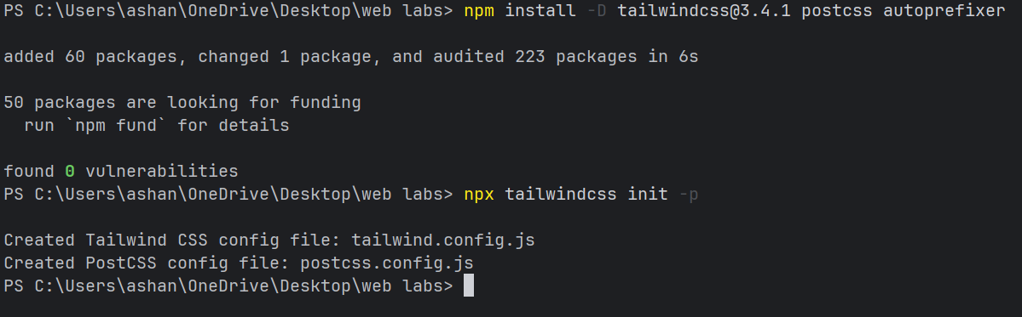

- Create a component from Tailwind css and Pass props into it.

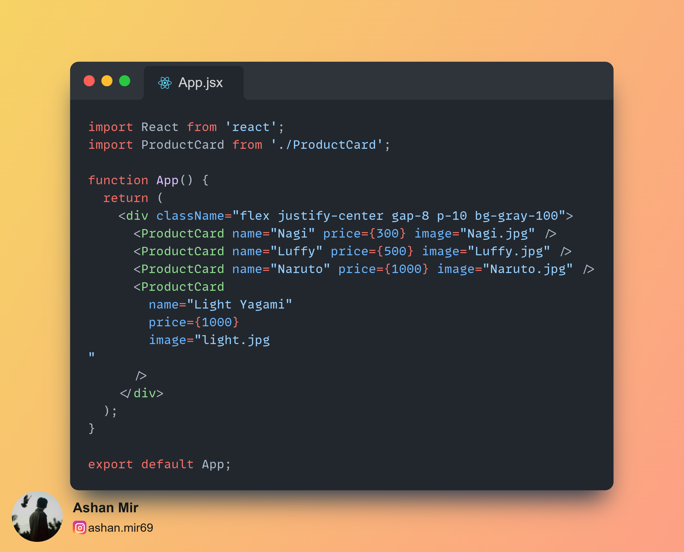

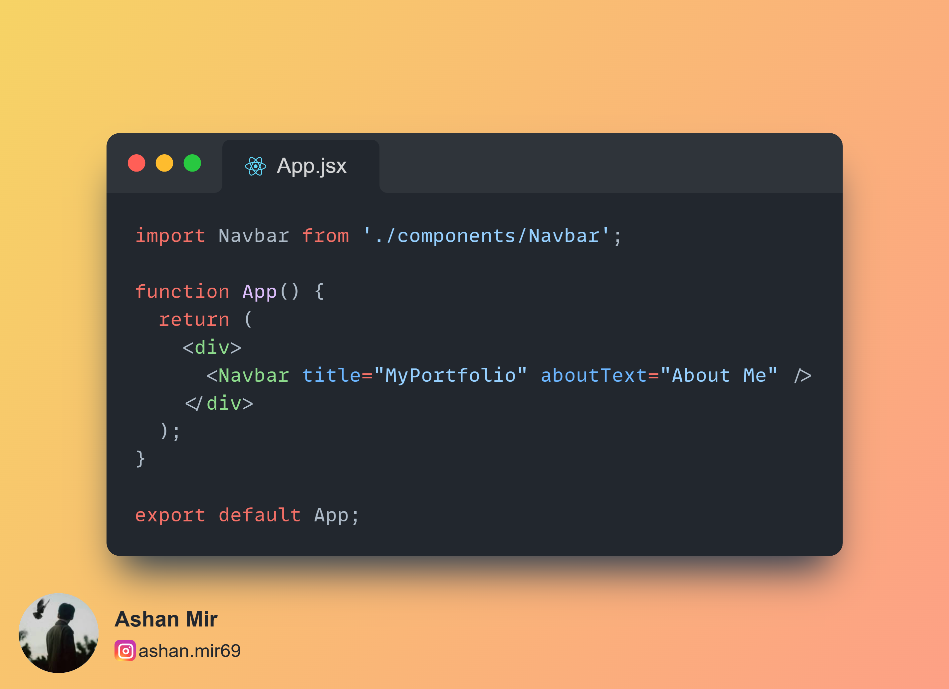

Output:


- Create your CV with three components from Bootstrap: Card, Accordion and Progress

